**AGRICULTURAL ECONOMICS DEPARTMENT CATALOGUE**

Kahramanmaraş Sütçü İmam University Faculty of Agriculture Department of Agricultural Economics has two main branches: agricultural management, agricultural policy and publication. The department aims to train experts with the necessary equipment to determine, define, classify and produce solutions to agricultural problems using the basic principles of economics.

✓ Our department, which provides the opportunity to study engineering with equal weight points, accepts students with equal weight points.

✓ Students who graduate from the department;

* In the Ministry of Agriculture and Forestry
* State Water Affairs,
* In the Ministry of Environment, Urbanization and Climate Change,
* Development Agencies, Agriculture and Rural Development Support Institution,
* In municipalities,
* In private insurance companies that provide agricultural insurance,
* In private banks,
* In agricultural publication and consultancy companies,
* In agricultural cooperatives,
* In commodity exchanges,
* In producer unions,
* In chambers of agriculture,
* In companies that do foreign trade of agricultural products, agricultural medicine, fertilizer, feed and seed production and marketing,

In addition, they find the opportunity to work in many areas such as the public, private sector, universities and research institutes.

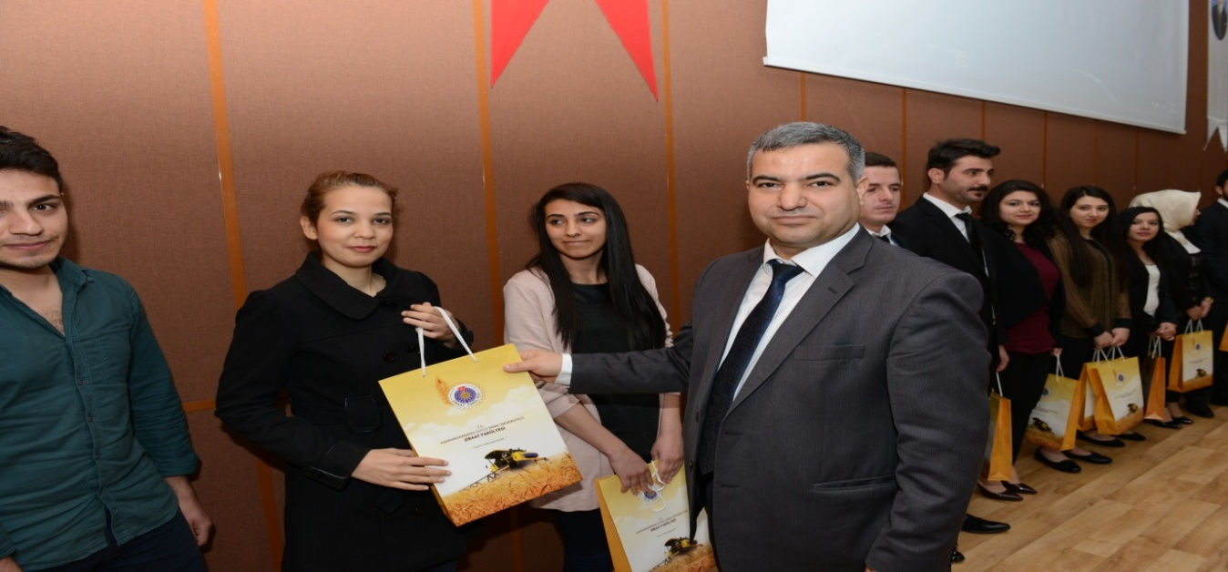

**Our Vision:** To be a department that can provide quality education and training in national and international environments, cooperates, coordinates and shares with national and international institutions and organizations in terms of interaction with new technologies and world standards, has entered into an effective and rapid adaptation process to information sources, carries out R&D activities and undertakes current projects, and contributes to local, regional, national and universal development with the information and technology it will produce.

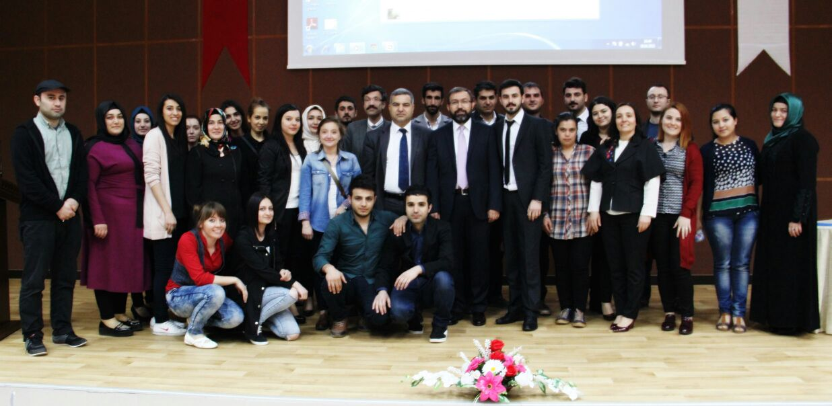

**Our Mission:** To raise well-equipped, scientifically ethical and entrepreneurial individuals who will take on roles in the leadership cadres of Turkish agriculture in the future, who have received qualified undergraduate and graduate education in the light of universal values, in which basic science, economics and engineering disciplines are handled together; to carry out projects and economic analyses to develop agricultural enterprises and rural structure in the region, to produce policies and to provide publication services to farmers and producers.